Task GAP analysis
A simple tool for all the difference in the world
Feel success in life
Start doing – what you do happens

Any subject and content can be used in this template for change,

Just do it

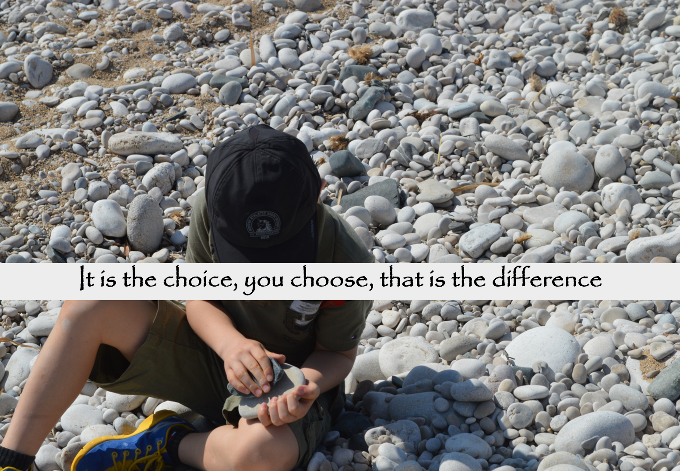

Step 1

Define your way and what you want to do, make your choice and choose. What you set your mind out for is what you will work for happen.
You are the difference in all you do

Step 2
When you use the templates, you increase your changes of creating the results you really want because you have a change to see, what is it that I do today, and does what I do take me to the outcome I am seeking.
What I do creates my results.

Step 3
Results is what you put into it, remember your input and doings is your results.
The Agenda you follow will give you your results, and you need to keep doing and changing to create your results.

Task GAP analysis

 | Task | Define today | Define the gab on a scale from 1-10 | Inputs for improvements
See and feel it
 | What is changed | Define your way | What are you thinking | Inputs for improvements

