Job GAP analysis
A simple tool for great results
Your way to great success

First step
What do you want to change, know and think specific about, what you want in your job? New or same, think about what you do, how you do it, and why this is important to you.
Use the GAP tool step by step and create great result.

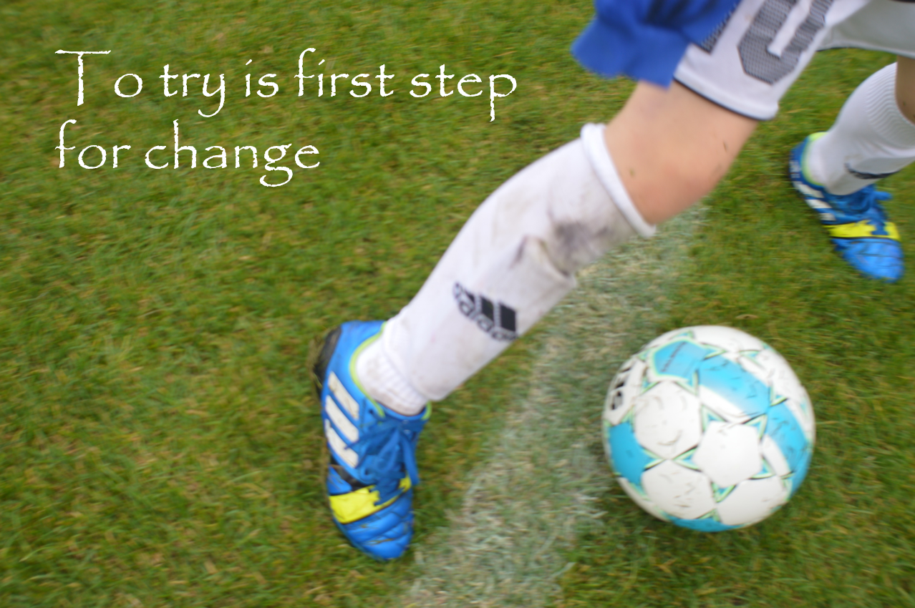

Next step
Use the tool to ensure you improvements, follow up upon yourself. Set a dead-line and make it happen.

Job GAP analysis

 | What kind of skills do I want to use | What am I good at | What do I need to improve | On a scale from 1-10 where am I today
NEXT step
 | What kind of skills do I use | What do I am improve | Where am I going | On a scale from 1-10 where am I today

To use the GAP TOOL is very powerful and effective. If you hold yourself up to, what you see in the templates you will have great results and thereby the change to create a great and even better life.

Your way to success
Your doings make the difference,
Your understanding and awareness is the difference

