Family GAP analysis
A simple tool to improve your family way

When we close our eyes and think about our way, we know that we see a picture of how we would like our
Family to be, that is our intention. When we really look at our family we see our outcome.
Is there a match, if not here is first step to take.

First step
First step is to look behind all the why’s. Find out what this is about, ask a least 5 why’s,
why do we do as we do, why are we screaming at each other, why do I feel you do not hear me,
why am I frustrated.
Take it as far as you can
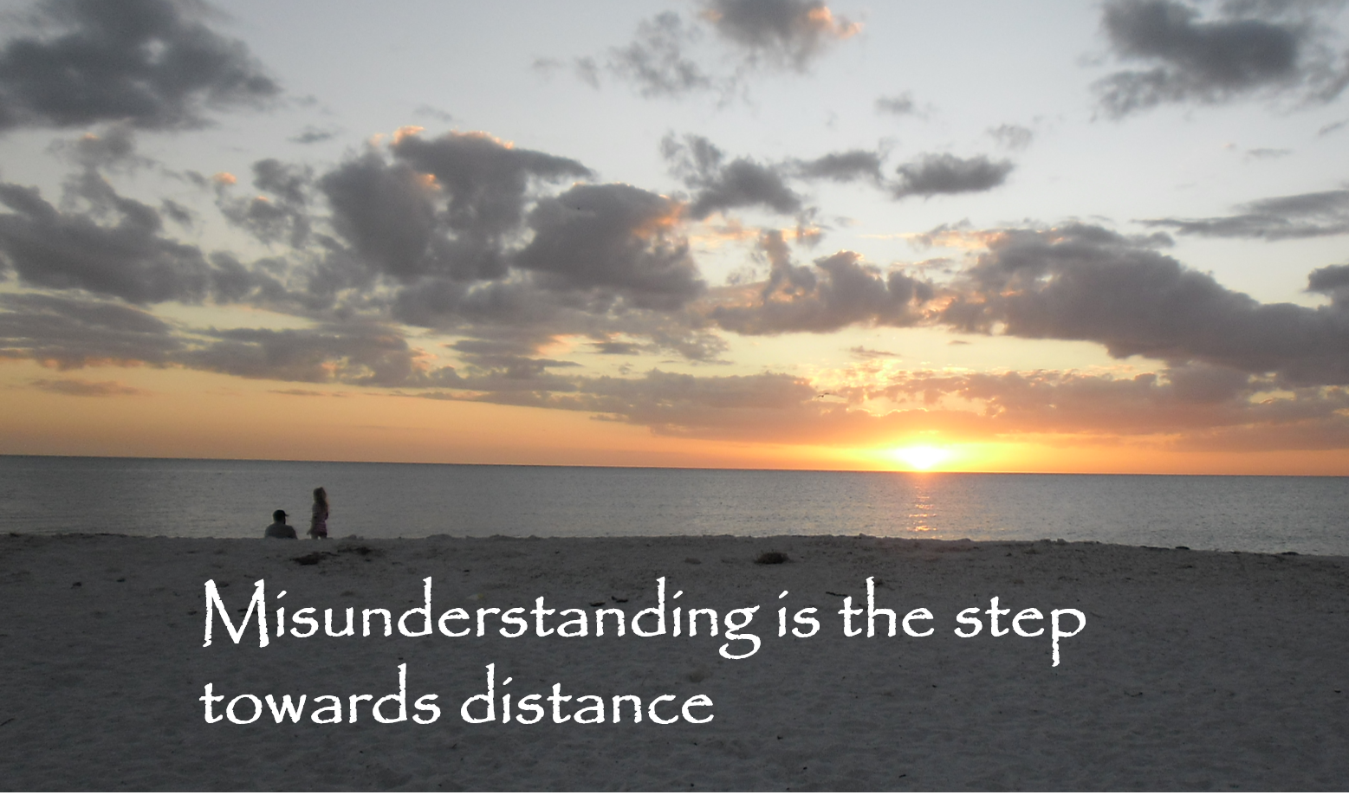

Step 2
Listen to each other and find out what the intention is, listen and listen again.
Use the GAP tool to follow up upon your way and create the results you are seeking.

Step 3
One of the first steps is to really start working, do it, first step is

- What goes wrong write all situations down
- What is the same
- What outcome do I want?
- How will I know I have changed?

 | What goes wrong, write all situations down | What is the same | What outcome do I want | How will I know I have changed

 | What goes wrong, write all situations down | What is the same | What outcome do I want | How will I know I have changed

 | What goes wrong, write all situations down | What is the same | What outcome do I want | How will I know I have changed

 | What goes wrong, write all situations down | What is the same | What outcome do I want | How will I know I have changed

 | What goes wrong, write all situations down | What is the same | What outcome do I want | How will I know I have changed

 | What goes wrong, write all situations down | What is the same | What outcome do I want | How will I know I have changed

 | What goes wrong, write all situations down | What is the same | What outcome do I want | How will I know I have changed

