Life GAP analysis
A simple template for great results
Make the analysis and create the difference
You can do it

First things first, and first things is to know where you stand, and to know where you should stand. In between is a GAP, what is the gap about, and what different behaviors are there in between. What do you need to do . Do you know ?
If not, use the analysis tool to find out what is in between the two levels.

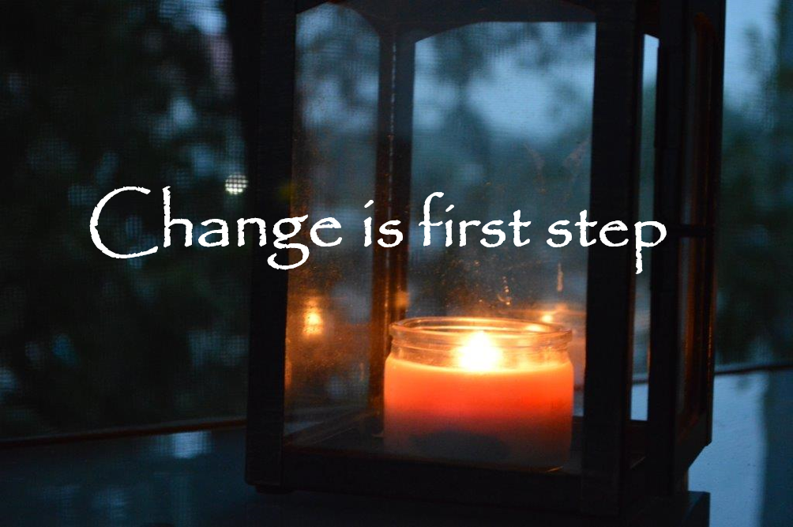

Step 1
The first step is to find out, what it is that you would like to be different. What are you thinking, how do you think about it? How do you want to think about it?

Step 2
Use the tool to engage, start working for the change you seek. There is only one, who can make the change. That is, you.
Start right now

Step 3
During your usage of the analysis, you may have questions to ask, and know that there is a FORUM within CAL where you talk about the Gaps in life, once you like to change, you will have many questions and you will seek answers. In CAL you will find help in this phase of your doing.
Step 4
Work for change, work to create the results you are seeking, do it because it matters to you, and because most important of all. You are the only one who can change your life to what you want it to be.
Follow up, and use the forums in CAL for all your questions, see the stories of other. Knowledge and know-how is all the difference in the world

Life GAP analysis
 | I know today  Where am I  What do I do | Scale from 1-10, how far away am I from where I want to be | Input , what can I do | Outcome  Where do I want to go
What Changed
 | I know today  Where am I  What do I do | Scale from 1-10, how far away am I from where I want to be | Input , what can I do | Outcome  Where do I want to go

